# CombineEvents

If there is a need to combine different independent monitors to one single 3-Byte-DTC in OBDonUDS, this should be done with a central mechanism.

Definition how to summarize the different data:

* **-IUMPR: output the lowest event Ratio for the DTC (same logic/algorithm like for IUMPR-grouping in 22 F8 xx)**
* **-Test result: If the DTC requires DTC based Test results CombineEvents is not available for this specific DTC.**
* **FreezeFrames:** 
  + **Output the first FreezeFrame from the event that first set the pending bit.**
  + **The latest FreezFrame will updated once a DCY with first occurrence of TestFailedThisDCY=1 in combined DTC Status Byte. More often updates are optional and OEM-specific.**
* Combining Logic
* 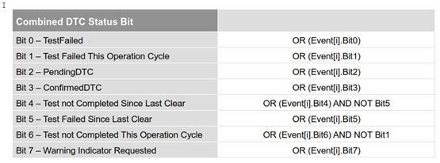

Permanent Status of DTC = OR (Event[i].permanentFlag)

All Bits, excluded Bit #4 and Bit #6 are an logical OR. DTC based readiness (Bit #4 and Bit #6) takes also in account that a fail makes the combined Monitor also completed.

All combined events in a DTC have to belong to the same readiness group.